SCANDINAVIAN /NORDIC CUISINES MENU

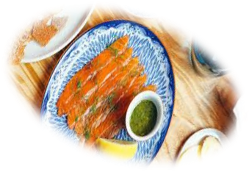
SALADS & APPETISERS
Whole Poached Salmon
Open-Faced Sandwiches
Lettuce, Tomato, Cucumber Salad
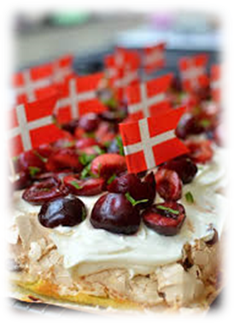
Mushroom Salad
Creamy Beetroot Salad
Cucumber Dill Salad
Carrot and Raisin Salad

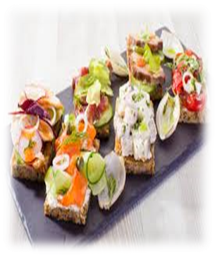
MAIN DISHES
Meatballs with Creamy Mushroom Sauce
Roasted Pork with Apple and Prunes
Butter-Steamed Potatoes
Roasted Root Vegetables
Macaroni Casserole
Karelian Stew
Scandinavian Cabbage Rolls

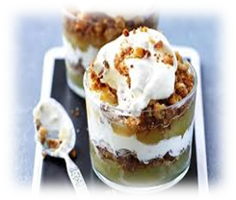
DESSERTS
Swedish Almond and Blueberry Torte
Danish Apple Trifle
Fresh Fruit / Fruit Salad

BREAD
Spiced Rye Bread
Price: € 8.00

